Social Media Post Content and Images

Facebook Sample Posts

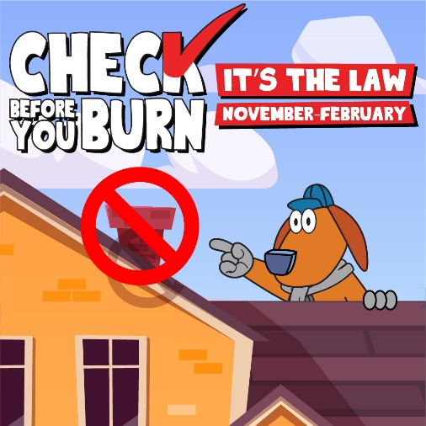
- Wood smoke, much like smoke from California wildfires, contains invisible particles that are small enough to enter the bloodstream and pose a serious health threat. Please remember to Check Before You Burn this winter and learn more about burn restrictions by visiting www.airquality.org/Residents/Fireplaces-Wood-Stoves/Check-Before-You-Burn.
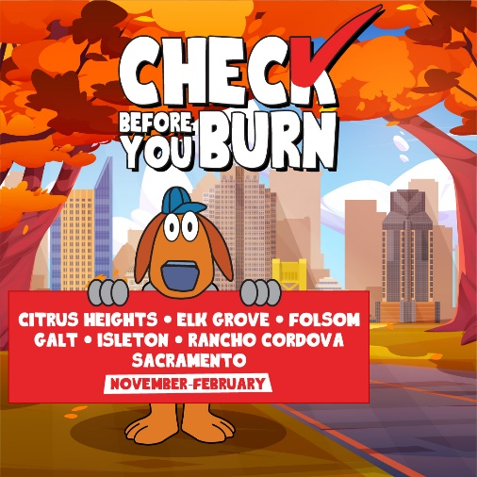
- The Sac Metro Air District’s annual #CheckBeforeYouBurn law is in effect from November 1 through the end of February. It restricts wood burning when fine particle pollution (PM2.5) is forecast to be high. Residents and businesses in Sacramento County and the cities of Citrus Heights, Elk Grove, Folsom, Galt, Isleton, Rancho Cordova, and Sacramento must check the Burn Day status daily before using a wood-burning fireplace or other wood-burning device.

- Checking the daily burn status is easy! Visit the Sac Metro Air District’s website to see when it’s legal to use your wood-burning fireplace or wood stove. www.airquality.org/Residents/Fireplaces-Wood-Stoves/Check-Before-You-Burn

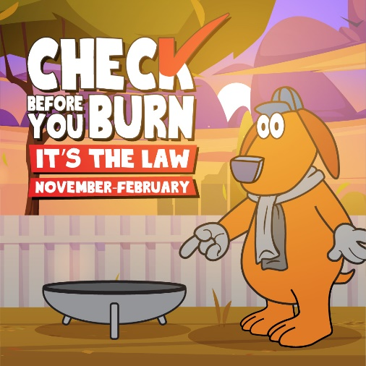
- On days when fine particulate pollution (PM2.5) is forecast to be high, the Sac Metro Air District restricts the burning of any solid fuel, including wood, pellets, or manufactured fire logs. Remember, if you spot wood burning on a day when it is prohibited, you can anonymously file a complaint by visiting www.airquality.org/Air-Quality-Health/Complaints.
- Breathing wood smoke is especially harmful for children because their lungs are still developing. Help your kids learn about the harmful effects of air pollution by visiting the Scooter’s World website with them. The website includes facts about air pollution, how you can help reduce air pollution, and fun activities for kids. Check out the website today at: www.AQMDscooter.com.

Twitter Sample Posts
.
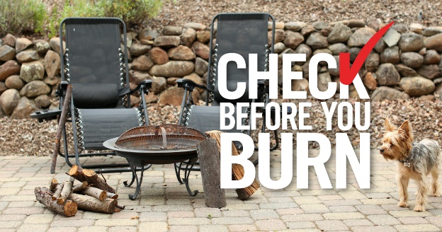
- Wood smoke contains invisible particles small enough to enter the bloodstream, including soot, smoke, metals, and more. Remember to #CheckBeforeYouBurn this winter and learn more about wood-burning restrictions by visiting: bit.ly/32ai7dk.

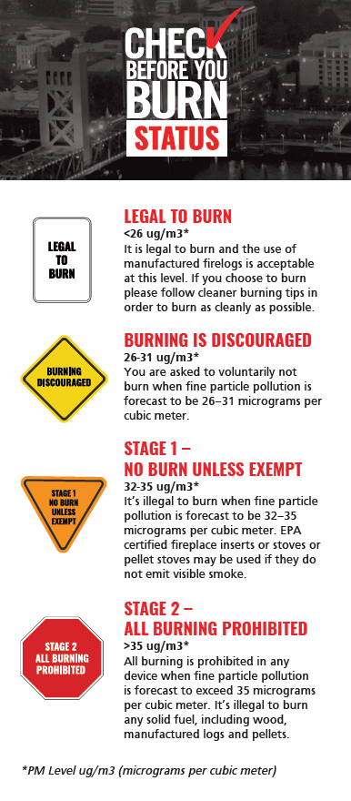
- The #CheckBeforeYouBurn law restricts wood burning when fine particle pollution (PM2.5) is forecast to be high. But, there are more than just “Legal to Burn” and “Burning Prohibited” days. Take a look at the four burn categories.

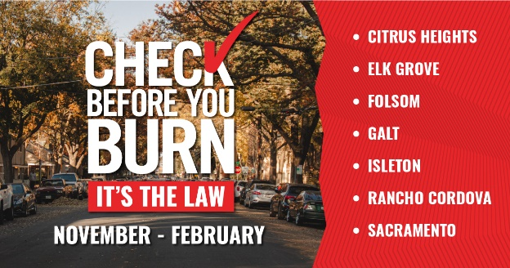
- #CheckBeforeYouBurn is the law in Sacramento County from Nov-Feb. Visit @AQMD’s CBYB webpage to find out when it’s legal to use your wood-burning fireplace or wood stove. www.airquality.org/CBYB

- Fine particle #airpollution (PM2.5) from wood burning poses a serious health threat and can increase the risk of asthma, heart attack, stroke and more. Please remember to #CheckBeforeYouBurn this winter – we’re in this together #SacramentoCounty! www.airquality.org/CBYB

Instagram Sample Posts

- Wood smoke contains invisible particles that are small enough to enter the bloodstream! This includes soot, metals, nitrates, sulfates, and dust. Remember, if you live in Sacramento County, you must #CheckBeforeYouBurn this winter to make sure when it’s legal to use your wood-burning fireplace, wood stove, chiminea or fire pit.

- These are three easy ways to see the daily #CheckBeforeYouBurn status. Make sure you keep an eye on when it is legal to burn any solid fuels in indoor or outdoor spaces! www.airquality.org/CBYB
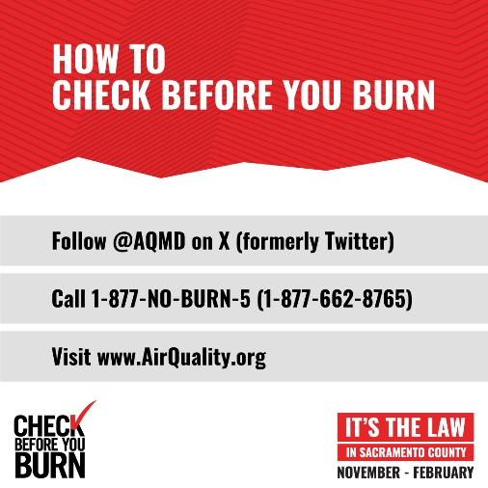

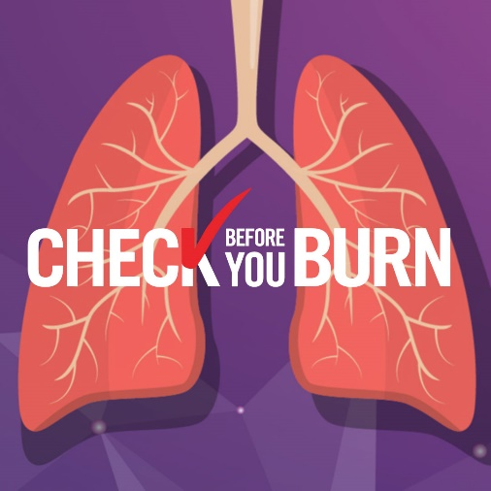
- Wood burning during the winter causes over 50 percent of the fine particle pollution (PM2.5) in Sacramento County. Wood smoke poses a serious health threat, including an increased risk of asthma, heart attack and stroke. Please be sure to #CheckBeforeYouBurn this winter. www.airquality.org/CBYB

- There are many reasons not to burn wood – one big reason is that smoke from chimneys can re-enter your home or enter your neighbor’s home, even when the doors and windows are closed. www.airquality.org/CBYB

