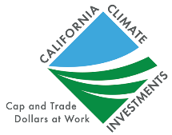
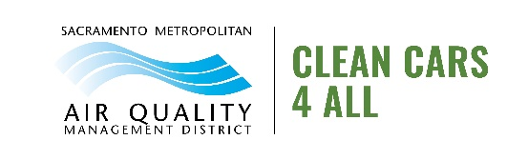
Sac Metro Air District
Clean Cars 4 All | Outreach Toolkit

Help Spread the Word About Clean Cars 4 All!

No one knows your community like you! These resources have been developed to spread the word about CC4A, but we invite you to make modifications that make sense and increase the effectiveness of these promotions. Representation and equity are cornerstones of this program. We are reaching out to you to help us build awareness of this program in your community. Please share this toolkit with organizations and individuals you think would benefit from the CC4A program. We appreciate your organization’s time, effort, and feedback.

Connect with the Sac Metro Air District and California Climate Investments on Social Media
- Follow @AQMD on Twitter
- @CAClimateInvest on Twitter and Facebook

Date | Facebook or Instagram
 | Need cleaner, more reliable transportation and up to $9,500 in down-payment assistance? Check out Sac Metro Air District’s Clean Cars 4 All program at SacCleanCars4All.org to find out if you are eligible! @CaClimateInvest #CAClimateInvestments #capandtrade #SacCC4A
Ready to turn in your 2007 model year or older vehicle for up to $9,500 towards something cleaner and more reliable? Go to SacCleanCars4All.org to see if Sac Metro Air District’s Clean Cars 4 All @CaClimateInvest program is right for you!
#CAClimateInvestments #capandtrade #SacCC4A
Do you live in Sacramento County? Are you ready to save money and the environment by going electric? Do you have a 2007 model year or older vehicle? Sac Metro Air District and @CaClimateInvest want to help you get into an electric vehicle, and they’ll even help you pay for it! Check out Clean Cars 4 All at SacCleanCars4All.org and see if you qualify for up to $9,500 in down-payment assistance.
#CAClimateInvestments #capandtrade #SacCC4A
Is your car costing you too much in gas and repairs? Are you in need of more reliable or safer transportation? If you have an older vehicle that needs replacing, the Sac Metro Air District wants to help! Check out SacCleanCars4All.org and take the eligibility quiz to see if you qualify for up to $9,500 in down-payment assistance in exchange for turning in your older and more polluting vehicle.
#CAClimateInvestments #capandtrade #SacCC4A
Improve #AirQuality and treat yourself - Apply to Clean Cars 4 All! Eligible applicants can receive up to $9,500 from @AQMD for a new or used electric vehicle when you scrap your old car. Visit www.SacCleanCars4All.org to check your eligibility and learn more about the program
#SacCC4A #CAClimateInvestments #Capandtrade

Date | Twitter
If you’re in the market for a new car, @AQMD and @CaClimateInvest want to help! Clean Cars 4 All offers grants of up to $9,500 to help income-qualified residents replace their old cars with hybrid or all-electric cars. Check your eligibility at www.SacCleanCars4All.org
#SacCC4A
 | Apply for Clean Cars 4 All today! This @AQMD program will give you money to replace your current car with a hybrid or all-electric car. Vehicle and income restrictions apply. See if you’re eligible at www.SacCleanCars4All.org #SacCC4A #CaClimateInvestments #Capandtrade
Improve #AirQuality and treat yourself - Apply to Clean Cars 4 All! Eligible applicants can receive up to $9,500 from @AQMD for a new or used electric vehicle when you scrap your old car. Visit www.SacCleanCars4All.org to check your eligibility and learn more about the program
#SacCC4A #CAClimateInvestments #Capandtrade
 | If you’re considering replacing a car, go electric and let @CaClimateInvest and @AQMD help pay! Income-eligible applicants can receive up to $9500 through Clean Cars 4 All for a hybrid or all-electric car. See if you’re eligible at www.SacCleanCars4All.org. #SacCC4A #AirQuality
 | If a new car has been on your radar, now is the time to make it happen! Clean Cars 4 All, funded by @CaClimateInvest and @AQMD, will help pay for a hybrid or all-electric car when you retire a car 15 years or older. Apply now and get up to $9500! #SacCC4A

E-Blast Template: let your email subscribers know about CC4A!

Subject: Get Up To $9,500 For A Down Payment Through Clean Cars 4 All!

On behalf of the Sac Metro Air District, [your organization] invites you to explore how Clean Cars 4 All (CC4A) can benefit you! The District has worked hard to secure California Climate Investment funding for Sacramento County’s income-qualified residents in the form of point-of-purchase-rebates (down-payment). When participants replace a 2007 model year or older vehicle, they can receive up to $9,500 for a cleaner, safer, and more reliable form of transportation. Like a grant, this money does not have to be paid back. We wish that our community benefits from the resources the Sac Metro Air District has worked hard to secure.

Visit www.SacCleanCars4All.org to take the CC4A Eligibility Quiz and view participant resources.

[signature]

Participant Profile: Share this CC4A Grantee’s Story in Your Community Newsletter

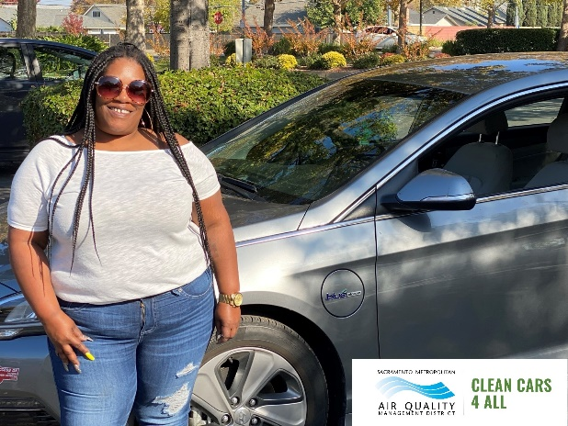
As a single mom with children to provide for and rent skyrocketing, purchasing a new car did not look within reach for Courtny. Receiving the Sacramento Metropolitan Air Quality Management District’s Clean Cars 4 All award letter (with values as high as $9,500) was a major turning point for Courtny. She immediately took the opportunity to purchase a new car from a participating dealership. Participating dealerships are trained to help Clean Cars 4 All participants find the best plug-in hybrid or all-battery electric vehicle that suits their individual needs.
Like many drivers, Courtny was looking to upgrade to a new vehicle but didn’t know if it made sense to do so right now during the middle of the COVID-19 pandemic. Additionally, she had concerns about the ability to afford a new car, especially an electric or plug-in hybrid vehicle. Courtny found out about the Sac Metro Air District’s Clean Cars 4 All program through her sister. This program offers participants up to $9,500 to purchase or lease a battery electric vehicle, fuel cell vehicle, or plug-in hybrid when they trade in their car with the model year of 2005 or older.
Clean Cars 4 All perfectly fit what Courtny was looking for—the opportunity to trade in her old 2001 Honda with 300,000 miles on it, in exchange for financial support to buy a new or used clean air vehicle. After learning about the program, Courtny immediately went to the Clean Cars 4 All website. There, she was able to begin the process to safely get rid of her old Honda and upgrade to a newer, cleaner, and more efficient car. Courtny greatly appreciated the help she received from a participating dealership where they prepared five different models to show her. After test driving all five cars, Courtny decided to purchase a 2017 Hyundai plug-in hybrid.
When going through the application process, applicants are asked to provide appropriate documentation for their vehicle, residence, income verification, and pass a vehicle operability inspection. While these may seem like daunting tasks, applicants are assigned case managers who support applicants through the entire application and car purchasing processes. Case managers are applicants’ primary contact in the program and work with applicants to make sure they successfully receive an award letter from the program. Case managers also offer guidance and additional resources during the car purchasing phase. Courtny appreciated not being left “high and dry” and maintained communication over email and phone with her case manager throughout the program.
Going from a car with 300,000 miles to a plug-in-hybrid with barely 16,000 miles gives Courtny peace of mind. When you wake up and get ready for work, nobody wants to worry about whether or not their car is going to start or how much gas their car is going to guzzle during the day. Her new car provides her with that sense of relief. Courtny loves that her car is efficient and reliable—saving her time and money at the gas station and repair shop. Plus, her children absolutely love her new car. Clean Cars 4 All is part of California Climate Investments, a statewide initiative that puts billions of Cap-and-Trade dollars to work reducing greenhouse gas emissions, strengthening the economy, and improving public health and the environment — particularly in disadvantaged communities. ​

Program Logos
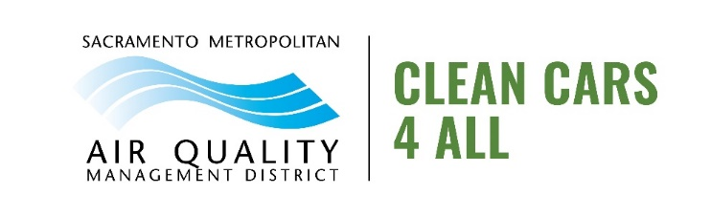
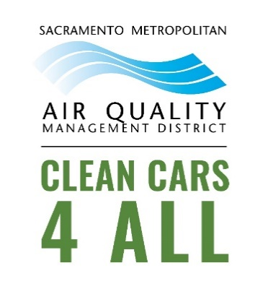

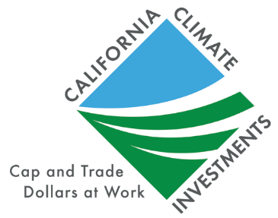

Participant Photos
