**Supplemental Environmental Project**

**Outreach Tool Kit**

The Sac Metro Air District's Supplemental Environmental Project (SEP) Program allows community-based projects to be funded from a portion of the penalties received during a settlement of enforcement actions. SEPs can improve public health, reduce air pollution, increase environmental compliance, and bring public awareness to neighborhoods most burdened by air pollution.

We need your help to share the word with our communities. These resources have been developed to spread the word about our SEPs solicitation, but we invite you to make modifications that make sense to increase the effectiveness of these promotions. Please share this toolkit with organizations and individuals you think would be interested. We appreciate your organization's time, effort, and feedback.

If you have any questions on this program, please reach out to [compliance@airquality.org](mailto:compliance@airquality.org) or 1-800-880-9025.

**Social Media**

Connect with the Sac Metro Air District on Social Media

* Follow @AQMD on Twitter

Twitter

@AQMD is accepting applications for Supplemental Environmental Projects. Learn how #AirQuality violators can fund your project to offset air pollution and improve our community. Visit <http://bit.ly/SacAirSEP> to submit your project application today! Applications due by 7/30/21.

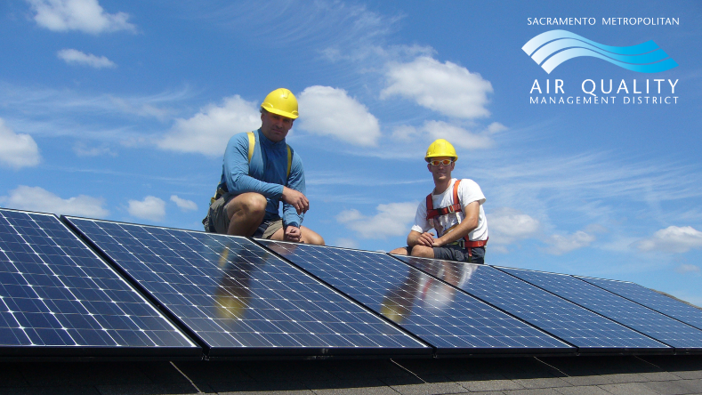

*Other photo options are available below

Facebook or Instagram

Have a project related to improving our #AirQuality? The Sac Metro Air District is accepting applications for Supplemental Environmental Projects. Learn how air quality violators can fund your project to offset pollution and improve our community. Visit <http://bit.ly/SacAirSEP> to submit your project application today! Applications due by 7/30/21.

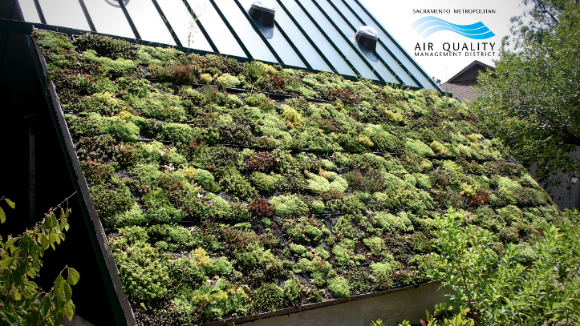

*Other photo options are available below

**E-Blast Template**

Let your email subscribers know about the Sac Metro Air District SEP solicitation!

Subject: Funding available for Community Projects related to Air Quality

Do you have a project related to improving our air quality in Sacramento County? On behalf of the Sac Metro Air District, [your organization] invites you to submit your Supplemental Environmental Project application today.

Any authorized representative of a community-based organization, nonprofit organization, public agency, academic institution, or tribal organization may apply.

Projects must be in a District Priority Community and fall in at least one of the following categories:

**Air Pollution Prevention or Reduction:** Prevent or reduce air pollution or greenhouse gas emissions.

**Air Quality Related Education or Compliance Training**: Assist educators, schools, and community groups to conduct training and public awareness campaigns to the business community or the public.

**Community Air Monitoring**: Provide tools to be used by trained members of the public for data collection and enhancement of existing air quality monitoring stations.

**Environmental Restoration and Protection**: Improve or restore the quality of the environment. The project must be related to air quality or climate change.

**Other**: Projects considered on a case-by-case basis if there is a demonstrated substantial health or environmental benefit and are consistent with the District SEP Policy.

Online applications must be submitted by 5:00 p.m. (Pacific Time), Friday, July 30, 2021. For more details, go to <http://bit.ly/SacAirSEP>.

[Signature]

**Newsletter Article**

Have a project related to Air Quality? The Sac Metro Air District's Supplemental Environmental Project (SEP) program is now accepting applications. The SEP program allows community-based projects to be funded from a portion of the penalties received during a settlement of enforcement actions. SEPs can improve public health, reduce air pollution, increase environmental compliance, and bring public awareness to neighborhoods most burdened by air pollution.

Any authorized representative of a community-based organization, nonprofit organization, public agency, academic institution, or tribal organization may apply.

Projects must be in a District Priority Community and fall in at least one of the following categories:

**Air Pollution Prevention or Reduction:** Prevent or reduce air pollution or greenhouse gas emissions.

**Air Quality Related Education or Compliance Training**: Assist educators, schools, and community groups to conduct training and public awareness campaigns to the business community or the public.

**Community Air Monitoring**: Provide tools to be used by trained members of the public for data collection and enhancement of existing air quality monitoring stations.

**Environmental Restoration and Protection**: Improve or restore the quality of the environment. The project must be related to air quality or climate change.

**Other**: Projects considered on a case-by-case basis if there is a demonstrated substantial health or environmental benefit and are consistent with the District SEP Policy.

Online applications must be submitted by 5:00 p.m. (Pacific Time), Friday, July 30, 2021.

For more details, go to <http://bit.ly/SacAirSEP>

**Logos**

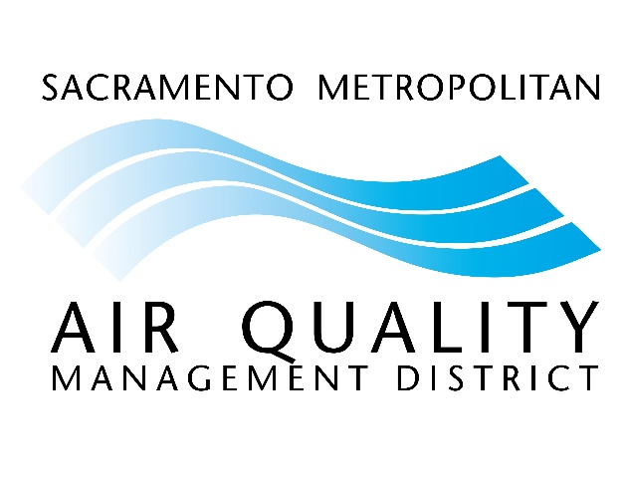

**Photos**

