Newsletter Articles

Article 1 – Check Before You Burn Season is Underway!

It’s the season to Check Before You Burn! This law is in effect from November 1 through the end of February and applies to residents and businesses in Sacramento County and the cities of Citrus Heights, Elk Grove, Folsom, Galt, Isleton, Rancho Cordova, and Sacramento.

To avoid further air pollution in our community, and to protect public health, the Sac Metro Air District will restrict or prohibit the use of all fireplaces, wood stoves, inserts, fire pits and chimineas when fine particulate pollution (PM2.5) is forecast to be high. It is important to check the issued daily burn status before using any of these items. Wood burning during the winter months causes more than 50 percent of the air pollution in Sacramento County.

PM 2.5 air pollution can pose a serious health threat when winter weather conditions trap the particulate matter close to the ground where we breathe. Wood smoke, much like the smoke from wildfires that plague California, contains invisible particles that are small enough to enter the bloodstream, including soot, smoke, metals, nitrates, sulfates, and dust. Breathing particulate matter air is especially harmful for children, older adults. or anyone with a pre-existing heart or lung condition, and can increase the risk of asthma, heart attack, stroke. and many other health problems.

Here’s how to Check Before You Burn, or know when a “No Burn Day” is issued:

- Follow the Sac Metro Air District on X (formerly Twitter) @AQMD
- Visit www.AirQuality.org/CBYB
- Sign up for daily Air Alert emails at www.SpareTheAir.com – input your Sacramento County zip code and mark the “Daily Air Quality Forecast” option
- Call 1-877-NO-BURN-5 (1-877-662-8765)

Check Before You Burn is implemented by the Sac Metro Air District in Sacramento County. The program provides the public with the same-day and next-day burn status.

Article 2 – Air Pollution Doesn’t Take a Holiday

It’s time to put on warm fuzzy socks, layer up with a cozy sweater and blanket and stay warm with your favorite hot drink! These are just a few ways you can stay warm without using a wood-burning fireplace this holiday season. If you decide to light up the Yuletide log this winter, make sure you Check Before You Burn… it’s the law in Sacramento County!

Wood burning can lead to an unhealthy amount of fine particulate matter (PM2.5) in the air (both indoors and outdoors), which is bad for our respiratory systems. Cold nights with little or no wind can create an inversion layer that traps wood smoke close to the ground, where it can accumulate and negatively impact local air quality. Long-term exposure can cause serious health problems, including:

- Decreased lung function
- Aggravated asthma
- Development of chronic respiratory disease in children
- Irregular heartbeat
- Nonfatal heart attacks
- Premature death in people with heart or lung disease
- Increased susceptibility to heart and vascular disease for post-menopausal women
- Reduced blood clotting ability

The Sac Metro Air District enforces “No Burn Days” through the sighting of visible smoke by enforcement staff. Inspectors respond to complaints, take photos of violations and issue warning and violation letters by mail – no one comes to your door. If you spot or suspect burning on a day when it is prohibited, you can file a complaint.

For more information about the Check Before You Burn program, please visit www.AirQuality.org/CBYB.

Check Before You Burn is implemented by the Sac Metro Air District in Sacramento County. The program provides the public with the same-day and next-day burn status.

Article 3 – Five Reasons to Not Burn Wood
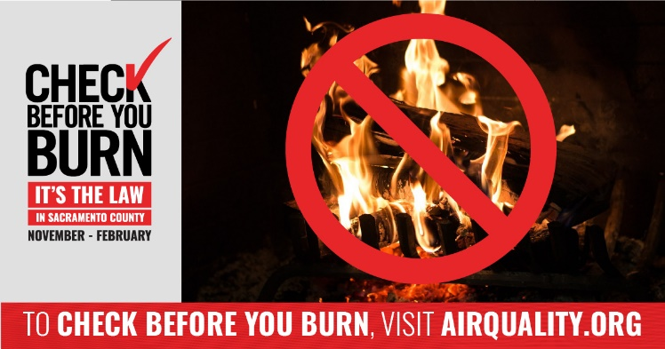

From November through February and on days when fine particle pollution is forecast to be high, the Sac Metro Air District restricts wood burning through the Check Before You Burn law. This regulation affects residents and businesses in Sacramento County and the cities of Citrus Heights, Elk Grove, Folsom, Galt, Isleton, Rancho Cordova, and Sacramento when fine particle pollution (PM2.5) is forecast to be high. The purpose of this law is to reduce the harmful emissions from wood and other solid fuel burning.

Here are five reasons not to burn wood:

- Particles from wood smoke trigger asthma attacks and can impact your heart and lungs.
- Wood smoke presents a significant health risk for older adults and the elderly.
- Children are more likely to suffer health effects from breathing wood smoke because their lungs are still developing.
- Smoke from chimneys can re-enter your home or your neighbor’s home even when doors and windows are closed.
- Particles from wood smoke contain toxins that can remain in your lungs for months, causing changes that lead to diseases and permanent damage.

To receive daily “No Burn Day” forecasts or learn more about the program, visit www.AirQuality.org/CBYB. You can also follow the Sac Metro Air District’s X (formerly Twitter) account “@AQMD” for same-day and next-day notifications.

Check Before You Burn is implemented by the Sac Metro Air District in Sacramento County. The program provides the public with the same-day and next-day burn status.

Article 4 – Tips for a Warmer Winter
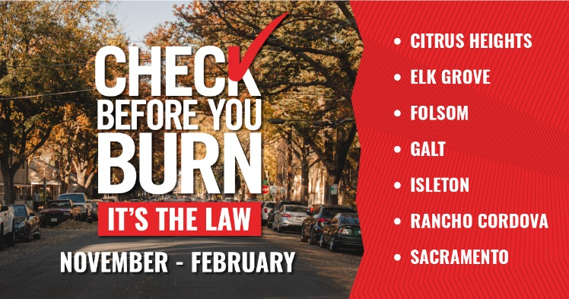

Winter is here and it’s chilly outside! We all want our homes to be cozy by keeping the heat in and the cold out. Before turning to a wood-burning fireplace, think twice about its negative health effects. Did you know that wood smoke consists of small harmful particles to the respiratory system called Particulate Matter 2.5 (PM2.5)? PM2.5 can trigger asthma attacks and other heart or lung problems. Here are some of the Sac Metro Air District’s tips for keeping warm without polluting the air.

- Bundle up. Your body temperature can change much faster than a room’s temperature. Instead of lighting a fire, put on another layer of clothing, whether it’s a sweatshirt, scarf, or hat.
- Break out the pool noodles. Yes, that’s right. According to the U.S. Department of Energy, drafts can increase your energy use by five to 30 percent. Use a pool noodle to block drafts. Just cut the pool noodle in half lengthwise, wrap it in fabric and slide it under your door. It will stay put and help keep you warm all winter long!
- Be a fan of your ceiling fan. Warm air rises, so run your fan on its lowest setting – clockwise – to push the warm air back down and into the room. This can reduce heating costs by 10 percent!

Be sure to always Check Before You Burn. First-time violations will result in a minimum fine of $50, with the option to pass a wood smoke awareness training class in lieu of paying the fine. Fines for subsequent violations will be higher.

To receive daily “No Burn Day” forecasts or learn more about the program, visit www.AirQuality.org/CBYB. You can also follow the Sac Metro Air District’s X (formerly Twitter) account “@AQMD” for same-day and next-day notifications.

Check Before You Burn is implemented by the Sac Metro Air District in Sacramento County. The program provides the public with the same-day and next-day burn status.

